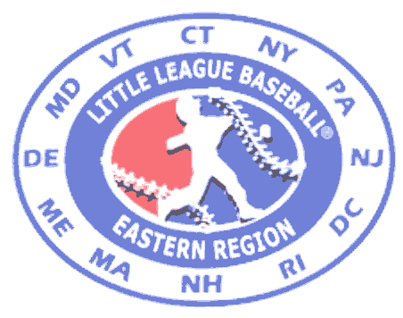


LITTLE LEAGUE
BASEBALL & SOFTBALL®

PRESIDENTS GUIDELINES FOR TOURNAMENT PLAY
(Updated May 15, 2025)

- You are responsible for all Little League Rules and District Guidelines.

2. The Host League only is responsible for the Game Director so . . . Appoint qualified Adults as Game Directors

3. Make sure Game Directors have and carry Game Directors Guidelines.

4. Remind you Managers and Coaches to act like ladies and gentlemen.

5. Remember you are responsible for the fans at your complexes
a. Unruly conduct will not be tolerated
b. Abuse of umpires and/or players will not be tolerated

6. Starting times for all games: Week Days Saturday Sunday
8, 9 & 10 Year Old Baseball 6:00 p.m. 3:00 p.m. 4:00 p.m.
9, 10 & 11 Year Old Baseball 6:00 p.m. 3:00 p.m. 4:00 p.m.
Little League Baseball 6:00 p.m. 3:00 p.m. 4:00 p.m.
Junior Baseball 5:30 p.m. 3:00 p.m. 4:00 p.m.
Senior League Baseball 5:30 p.m. 3:00 p.m. 4:00 p.m.
8, 9 & 10 Year Old Softball 5:30 p.m. 3:00 p.m. 4:00 p.m.
Little League Softball 6:00 p.m. 3:00 p.m. 4:00 p.m.
Junior League Softball 6:00 p.m. 3:00 p.m. 4:00 p.m.
Senior League Softball 6:00 p.m. 3:00 p.m. 4:00 p.m.

7. In case of rain, we will play the next day. No game times or dates are to be changed without the prior approval of Bill Serfass, Jr. These decisions are final and there will be no exceptions. The request must come from the league president and not managers or coaches.

8. It is mandatory that all your ball clubs carry their Affidavits, Maps, Tournament Player Verification Forms, School Enrollment Forms and/or, Proofs of Residency, and Diamond Leader Completion Certificate with them at all times.

9. The use of play calling bands by defensive players is permitted as well as hard items to control the hair, such as beads, are also permitted. To do this ahead of time will save time and the umpires’ patience at game time.

10. Patches are mandatory on all uniforms. Patches may not be sublimated or screen printed on the uniforms.

11. Each team is required to bring 2 new baseballs to all games. The host team will furnish all softballs. If played at a neutral site, both teams bring 4 softballs and the team winning the toss will furnish. Only baseballs and softballs from the approved Little League Tournament List are to be used.

- You need to have one (1) qualified adult umpire for each home game. Remember to send a qualified adult umpire to each away game and for the championship games where you will be required to bring one.

- If you win the toss for umpires and do not have a qualified umpire with you, you should not take home plate. Do not use parents of team members for umpires. Do not bring an umpire from out of the stands.

14. The District reserves the right to appoint the Game Director for any and all games at the District’s discretion. The District will supply the Director for District Championship and all Sectional Games.

